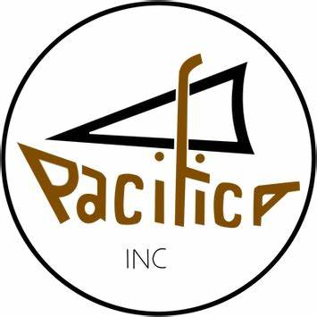
2023 National Conference & AGM
10 –12 February 2023
South Waikato Sport and Events Centre, Lions & Rotary Rooms
25 Mossop Road, Tokoroa, South Waikato

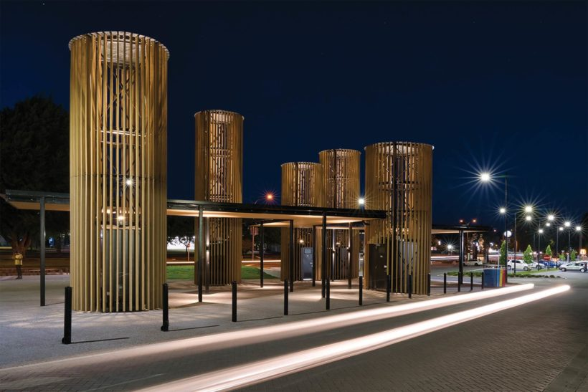
This is an image of Tokoroa Southern Cross Pacific Stars, Award Winning Architecture, Tokoroa Township SH1.
‘Women and girls’ resilience through Covid-19’

PROGRAMME
Friday 10th February 2023
Main Conference Event Centre
9am – 12pm | Registration Open
12pm – 1pm | Lunch
1pm – 3pm | Official Conference Opening  - Lotu  - Welcome – National President Rev Alofa Lale  - Branch reports  - Signing of the Memorandum of Understanding between New Horizons for Women Trust and PACIFICA Inc – Teupoko’ina Utanga Morgan Memorial Fund Awards  - PACIFICA Song  - Closing prayer
1.30pm – 3pm | Youth Programme  Facilitated by Savieti Lea, National Youth Rep
6pm – 10pm | Conference Dinner  Welcome  Opening prayer & grace  Dinner  Guest Speaker.  Speech competition – Women & Youth.  Closing prayer  Music, items & dancing.

Saturday 11th February 2023
Main Conference Event Centre
TIME | ACTIVITY
7.30am – 8.45am | Breakfast
8.45am – 9.00am | Lotu
9.00am | Electoral box OPENS for submitting hardcopy nominations and candidate acceptance forms. Returning officer available.
9.00am – 10.00am | Presentation & Talanoa - Pacific Health Strategy & Pacific Women’s Strategy.  Gerardine Clifford-Lidstone, CEO Ministry of Pacific Peoples (Incoming)  Corrina Grey, Ministry of Health  Lita Bourne, Ministry of Health
10.00am – 10.30am | Morning Tea
10.30am – 12.00pm | Activities - Local flavour | Youth activities
12.00pm | Electoral box CLOSES.
12.00pm – 1.00pm | Lunch
1.00pm – 3.00pm | AGM – National President & Executive Committee  Elections
3.00pm – 3.30pm | Afternoon Tea
3.30pm – 5.00pm | AGM continued  PACIFICA Song  Closing prayer
6.00pm – 12.00am | Conference Dinner  Welcome  Opening prayer & grace  Dinner  Keynote Speaker  Fashion Parade  Awards presentation  - Anna Marshall Memorial Award – highest percentage of registered members in attendance at National Conference.  - Ainu’u Seiuli Moira Walker Awards (new awards) – one young member and one mature member who has consistently displayed one or more exceptional qualities at the National Conference (an encourager, a mentor, a nurturer, as a voice, or a voice which she is finding, is confident or gaining confidence, she is proud of her heritage, and they have fun).  - Gifford Family Fashion Award – winner of the fashion show.  - Josephine Tiro Award – Best dressed branch at National Conference.  - Koro Puaka Shield – branch with the most registered members.  - Lineahi Lund Award – Activity of the year.  - Maori Women’s Welfare League Trophy – Winner of the open speech competition.  - Reuera Kavan Award – has the most members attending the National Conference.
TIME | ACTIVITY
Continued  6pm – 12am | - Tagaloatele Peggy Youth Award – most registered young members.  - Tofilau Bernadette Pereira Award – most colourful and vibrant person at National Conference.  - Vira Pokia Shield – Winner of the Young P.A.C.I.F.I.C.A Inc Speech competition.  Farewell 2021-2023 National President & Executive  Welcome 2023-2025 National President & Executive  Closing prayer  Music & Dancing.

Sunday 12th February 2023
TIME | ACTIVITY
7.00am – 8.30am | Breakfast
9.30am – 10.00am | Thanksgiving church service
10.30am | Brunch & Farewells.

NB: Please note some parts of the programme are subject to change.

