P.A.C.I.F.I.C.A Inc.
National AGM &Conference
KEY INFORMATION ON THE VENUE, ACCOMMODATION & LOCAL RESTAURANTS IN TOKOROA
VENUE
South Waikato Sport and Events Centre, 25 Mossop Road, Tokoroa, South Waikato. 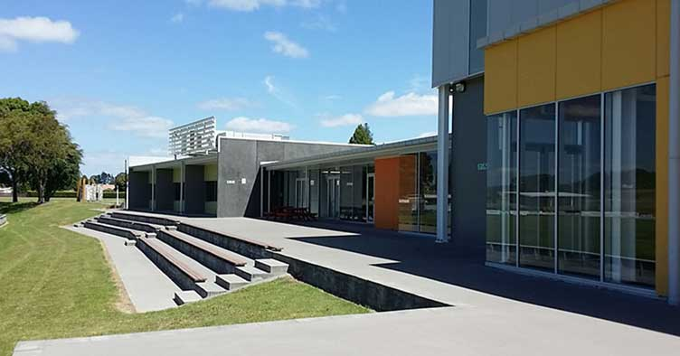
MAP - Please note all of the Conf & AGM programme will be located at this venue. 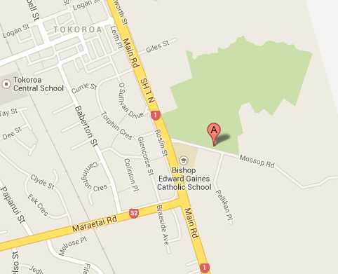

ACCOMMODATION IN TOKOROA
Branches are to arrange their own accommodation and travel.
If you are struggling to find appropriate accommodation, please email 2023pacificaconference@gmail.com as we may be able to assist.
St Lukes PIC church Hall (Marae style)
2 Kelso Street, Tokoroa 3420
Mattresses and pillows supplied but guests must bring own bedding/sleeping bag.
To book your accommodation please email 2023pacificaconference@gmail.com
$30 per person for Friday and Saturday nights.

Clifton Court Motel
+64 7 886 4579
111 Main Road
Tokoroa South Waikato 3491 New Zealand
Website: Clifton Court Motel | Tokoroa Accommodation | +64 7 886 4579
NB: Very close and in walking distance to the PACIFICA AGM and Conference venue.

Redwood Lodge Motel
SH1 North, Tokoroa, South Waikato
Ph: 07 886 8209
Email: redwood.lodge@xtra.co.nz
Website: Redwood Lodge Motel - Tokoroa Accommodation, New Zealand
NB: Close to venue. 1 min driving distance to the PACIFICA AGM and Conference venue. Not suitable for walking as it is located on the State Highway.

Mayfair Court Motel
22 Logan Street, Tokoroa, Central Business District
Ph: 07 8867339
Mayfair Court Motel | Tokoroa Accommodation | Home
NB: Very close and within safe 10 minute walk to PACIFICA AGM and Conference venue.

Amisfield Motel
www.amisfieldmotel.co.nz
22 Lochmaben Road Tokoroa 3420
07-886 7773

Tokoroa Motel Location of Amisfield Motel Accommodation in Tokoroa
NB: 1 min driving distance to the PACIFICA AGM and Conference venue. Not suitable for walking as the road entrance is located off the State Highway.

Nearby accommodation to Tokoroa

Lake Maraetai Lodge
https://lakemaraetailodge.co.nz/
27 Lake Road, Mangakino 3421
07 882 8810 or 0800627238
Email: office@lakemaraetailodge.co.nz

AirBnB
https://www.airbnb.co.nz/s/Tokoroa--New-Zealand/homes?adults=2&checkin=2023-02-10&checkout=2023-02-12

Putaruru Hotel
79 Princess St, Putaruru
Ph: 078833911
PUTARURU HOTEL - Updated 2022 Prices & Reviews (New Zealand) (tripadvisor.com)

Putaruru Arms Motor Lodge
92-94 Tirau St, Putaruru
Ph:078838307
PUTARURU ARMS MOTOR INN - Updated 2022 Prices & Motel Reviews (New Zealand) (tripadvisor.com)

Tirau Motor Inn
54 Main Road, Tirau
Ph: 7-883 1111
Tirau Motor Inn - Tirau Info

Marae Accommodation
The Marae opens to confirm its bookings/fees in January 2023. Please contact pacificatokoroabranch@gmail.com directly as the Marae does not take direct individual bookings.

Restaurants, Café’s and Take Away Outlets

Alberico
Commerce St and Logan St, Tokoroa
Ph: 078869457
albericos.nz

Robert Harris Café
Corner Warratah Place and 284 Main Highway SH1, Tokoroa
Home | Robert Harris

Rumbly Tumms
213 A Rosebery St, Tokoroa
Ph: 078860001
(20+) Rumbly Tums Cafe Tokoroa | Facebook

Nexus
38-44 Bridge St
Ph:078860072
https://nexusrestaurant.co.nz

Tokoroa Incorporated Club (Home of the RSA)
Chambers St, Tokoroa
Ph: 078865139 (ask for the Restaurant)
Tokoroa Club Inc. (thetokoroaclub.org)

Note: Tokoroa has numerous local Fish n Chip, Chinese, Thai and Indian dine in and takeaway outlets including KFC, Burger King and McDonalds. Please google additional venues as we have only provided you with some of the options available.

